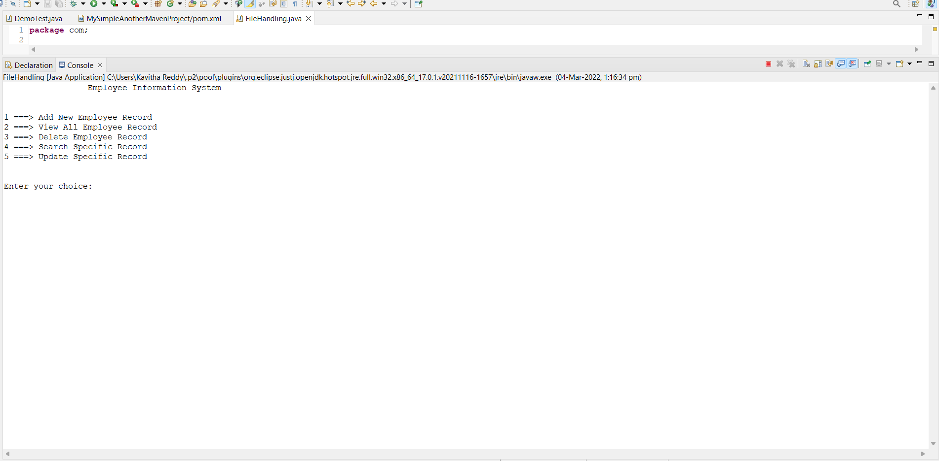

After Running Of My Code It Display This Page We Have To Select Our Choice

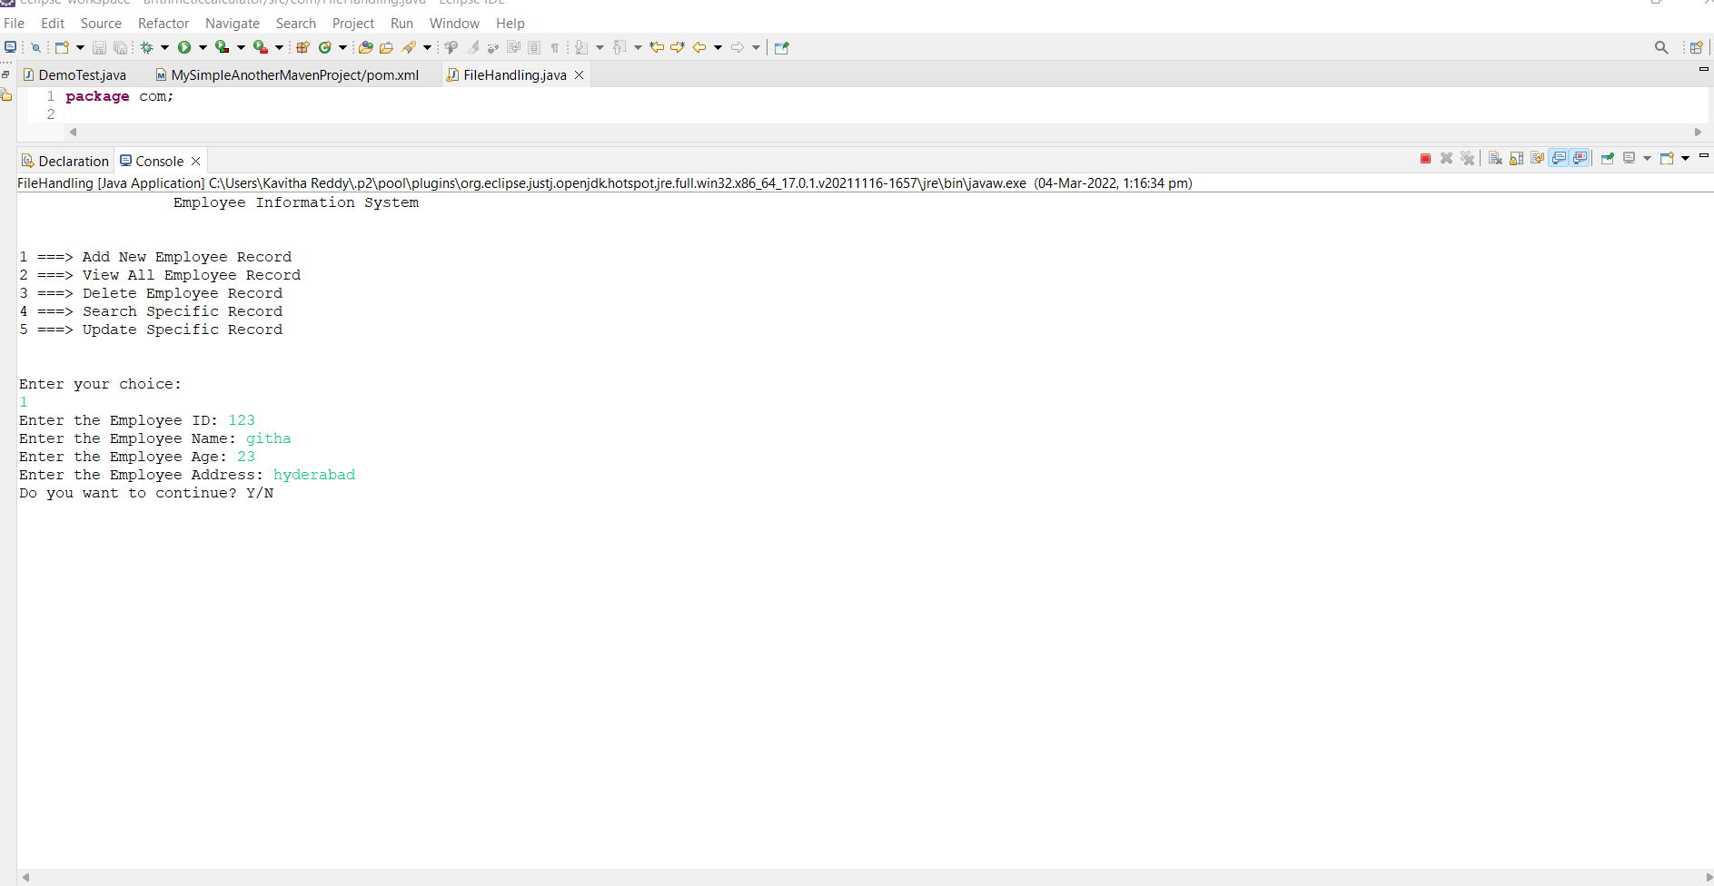

Now I selected my choice as 1 it ask to enter employee id ,name,age,address after entering all information it again ask you want to continue y/n.

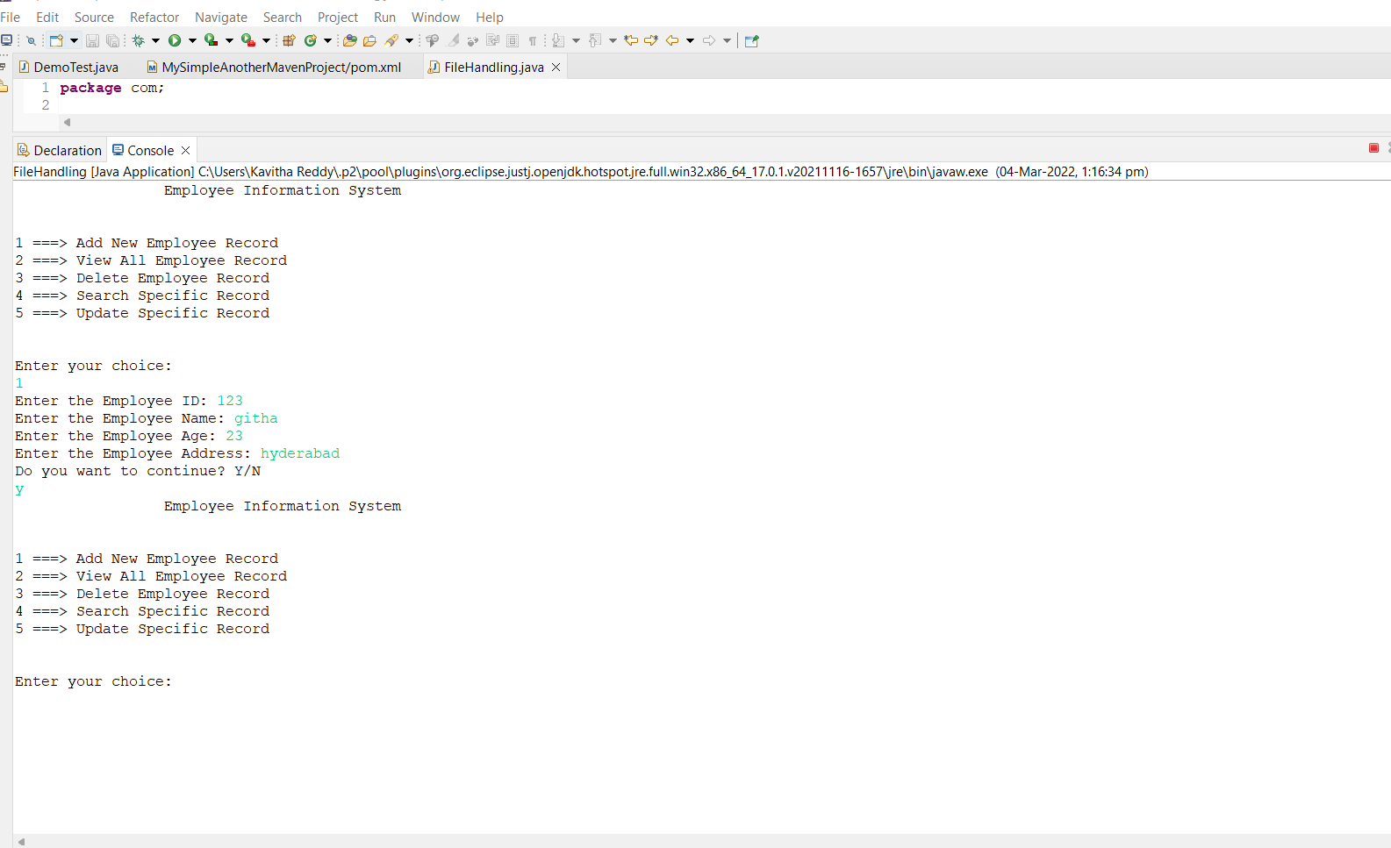

I selected y so, it again asking to select choice

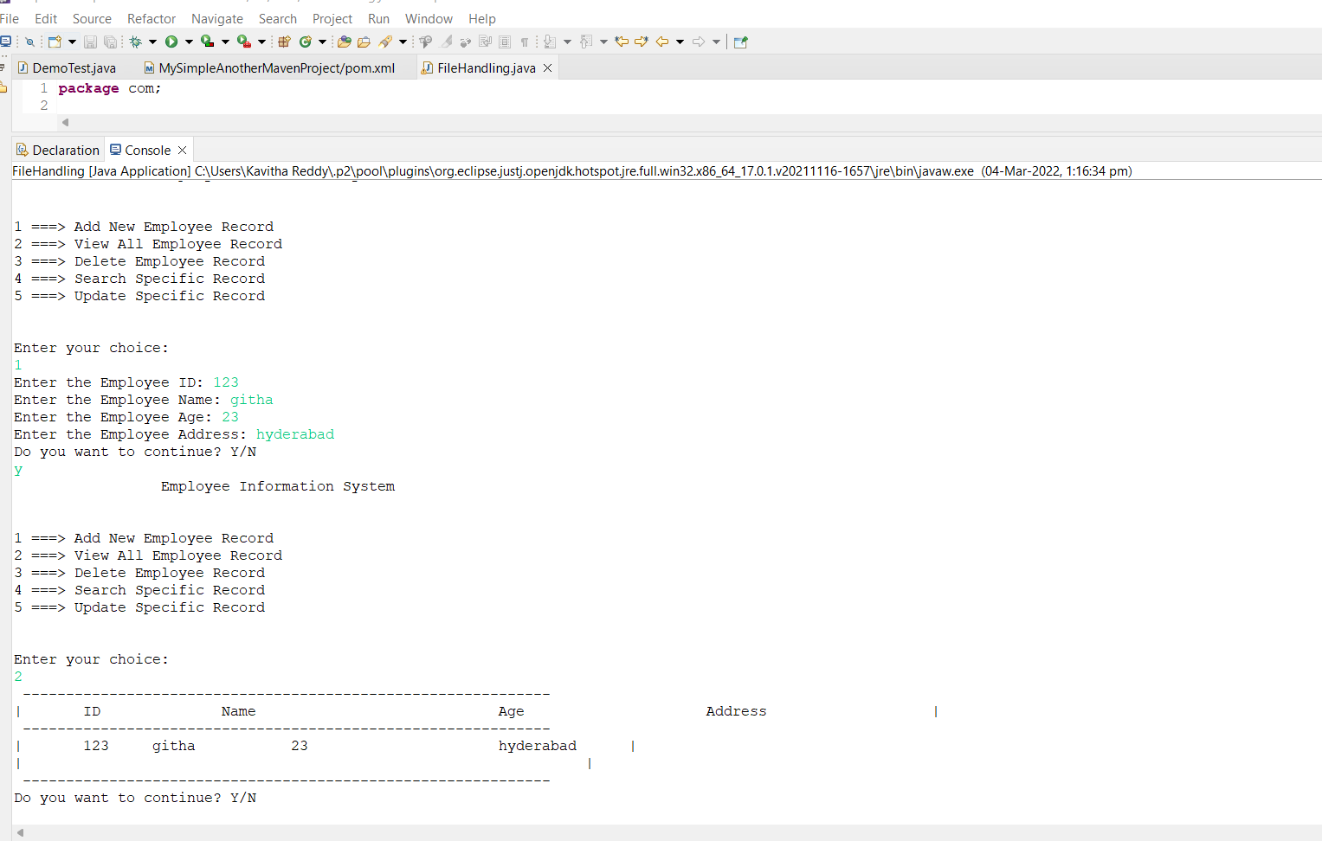

Now I selected 2 to display record so, it display the record as we added before

Again it is asking to continue or not

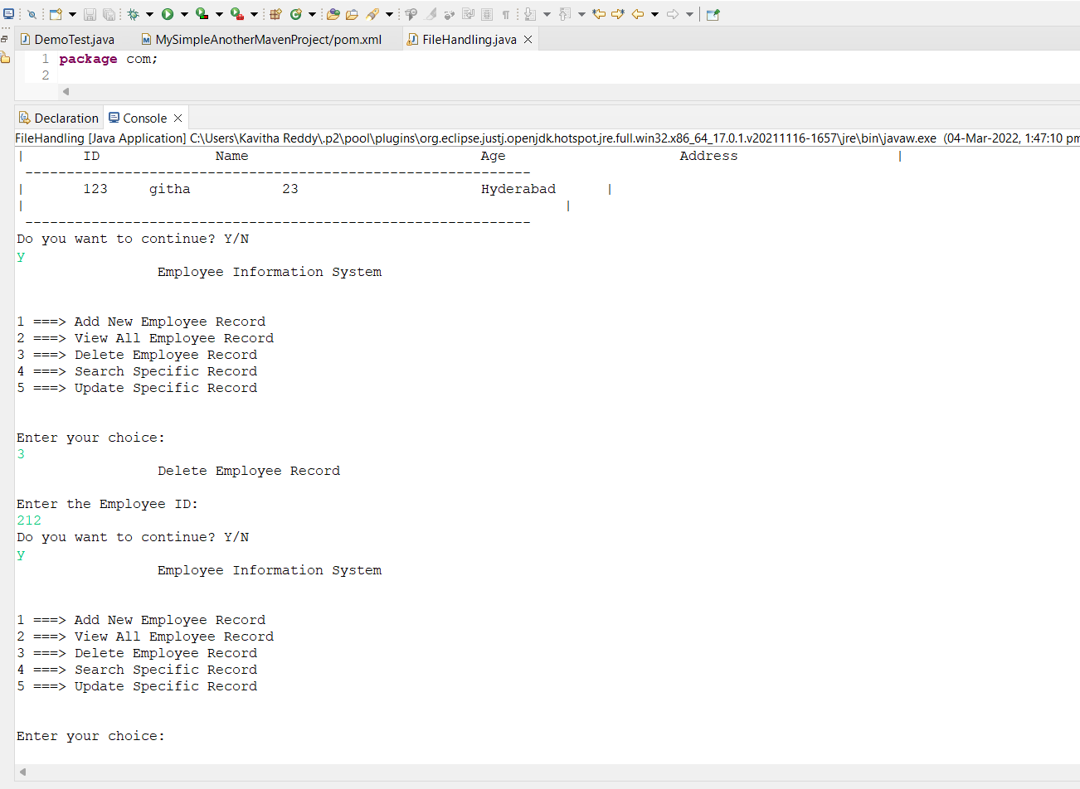

I selected y we have to select our choice

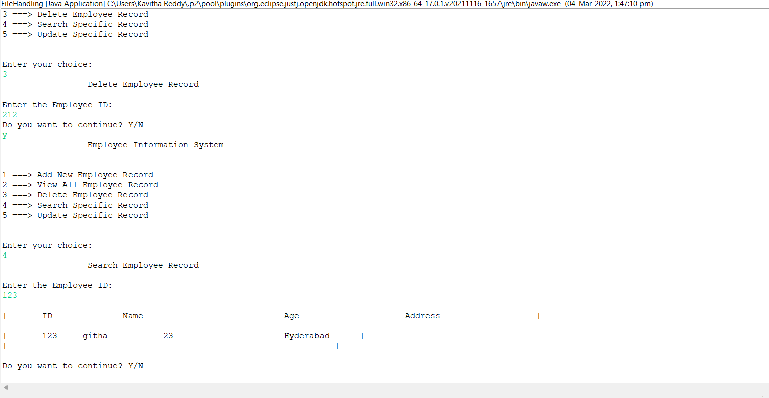

Now I selected 4 to search specific record it asking employee id if we enter employee id means it display record again asking to continue

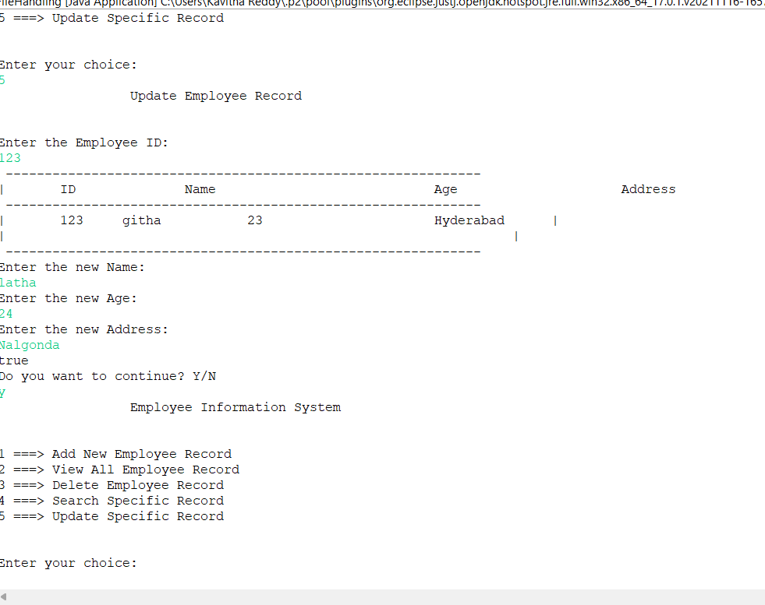

I selected 5th option to update my record we have to enter new name ,new age, new address and click y

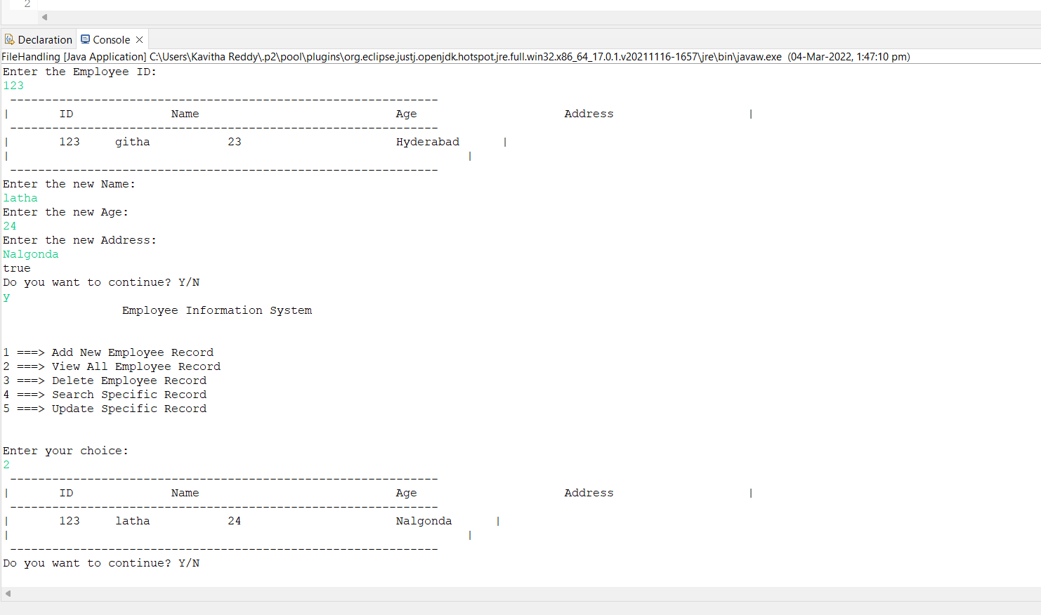

After update I selected 2 option to view is my record is updated or not yes my record is updated asking to continue

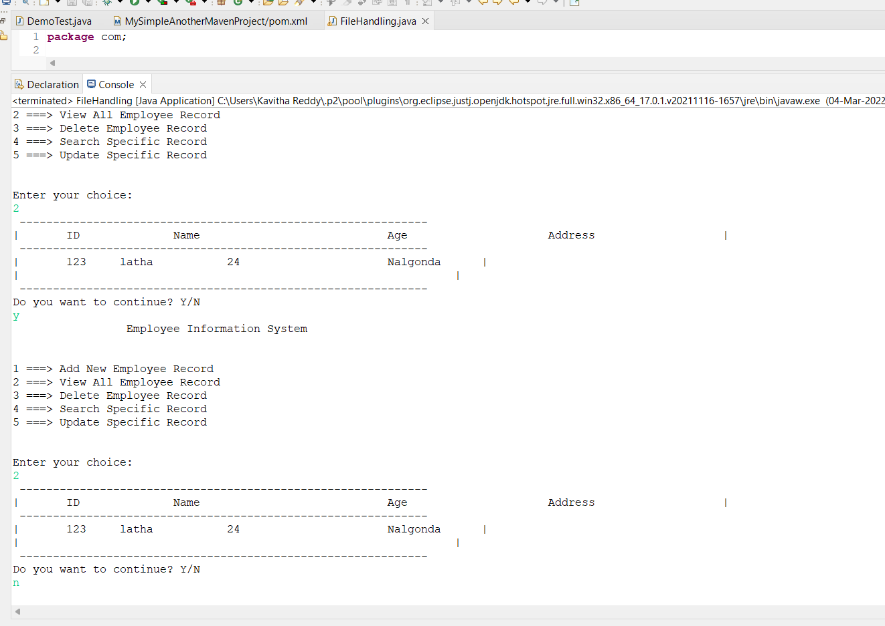

Now I selected n to stop